Algebra 1: Unit 4, Lesson 3

- Find the slope of the function represented by the table of values below.
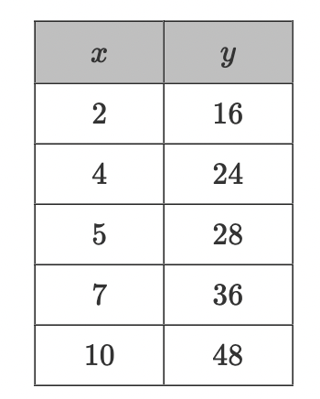
What is the slope of function?
4

- What is the slope of the line $y-3=\frac{1}{3}x+9$?
$$\frac{1}{3}$$

- Complete the table below.
Point-Slope Form | Function Notation
$$y-2=\frac{5}{4}(x-4)$$ | $$f\left(x\right)=\frac{5}{4}x-3$$
Slope-Intercept Form | ____________________
$$y=\frac{5}{4}x-3$$ | $$5x-4y=12$$
standard form

